Let’s find the positives!

Positivity, Kindness and Community
The kindness of strangers brings joy during the coronavirus despair.
Notice, the countless quiet good deeds done by ordinary people.
Rejoice at the people on the balconies in France, Spain and Italy who sing to their neighbours in the apartments above and below.
Across courtyards, they pump accordions and bang tambourines and saucepans, raising their voices in unity and lifting the spirits.
A mother and her daughter started a "street pantry" for the homeless - and others suddenly started keeping it well stocked.
Stillness Infants School’s donations for the local food bank came flooding in, not only with food, drinks, and toiletries, but with over £200.
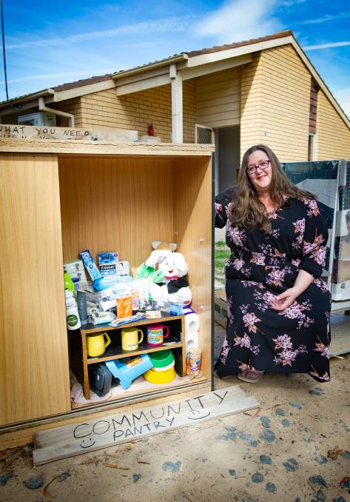

Check out these videos to see the kindness of strangers:
https://www.youtube.com/watch?time_continue=9&v=dhTjGS3QkYE&feature=emb_logo
https://www.youtube.com/watch?v=h2Rle1YS5Fs
https://www.youtube.com/watch?v=etfy2N0JUIo
https://www.youtube.com/watch?v=EBByYjjvNzs
https://www.youtube.com/watch?v=DDRiINXik00
https://www.youtube.com/watch?v=TF3e4WcY9SY

