Friday January 8th Remote Learning

If you would like additional educational games and activities to support the phonics feel free to use Phonics Play.
https://www.phonicsplay.co.uk/
https://www.phonicsplay.co.uk/resources/phase/2/buried-treasure

Friday | Teach | Activities
Phonics  Phonic sounds the week: a_e, e_e, i_e, o_e. | Today’s sound is o_e as in bloke. Write it down for your child to copy a few times, saying it as they do so.  Some o_e words – bone, bloke, folk, cone, stone, smoke, nose, hose, home, globe, throne, note, joke, alone, poke. | You and your child could play a try it both ways to help remember this spelling of the sound. As o_e makes the same sound as oa, you could say either an o_e word or an oa word and your child could try writing it out both ways; so if you said bone, they could try writing it as bone and boan, if you said boat, they could try writing it out as bote and boat.  Does one just look wrong? Are these words familiar enough for your child to be able to tell which is right from sight memory? Either way, it should help with remembering the digraphs.  Some ‘oa’ words – boat, moat, goat, road, loaf toast, roast, toad, road, float, soak, oak, cloak.
 | Spellings:  Old, cold, gold, hold, told, bath, path, class, pass, any, many. | Friday spelling test!  Ask your child to spell each word without looking.  How many did they get right? They can note down any they haven’t mastered yet in the back, so they can keep working on them!
English Focus:  Adverbs  Pages:  12 - 13 | Adverbs are words that describe verbs; a friendly wave, running quickly.  Adverbs often end in ‘ly’, but not always!  If you’re adding an ‘ly’ to a word to change it into an adverb and it already ends in ‘y’ – you change the ‘y’ to an ‘i’ then add ‘ly’ – messy turns to messily and funny turns to funnily. | Watch the video introducing today’s work, then work through the questions on page 13.  Then watch the video for the answers and the challenge.  The challenge will to be to write some sentences that have adverbs in them. For these the Man on the Moon book can be used. Also, if they want to, children could edit their verb sentences from yesterday, so if they wrote ‘The alien was drinking.’ They could change that into ‘The alien was drinking messily.’ More details will be in the video.
Maths Focus:  Shape and Patterns  Pages:  64 - 65 | Shapes can be made into patterns. These can be simple repeating patterns like these: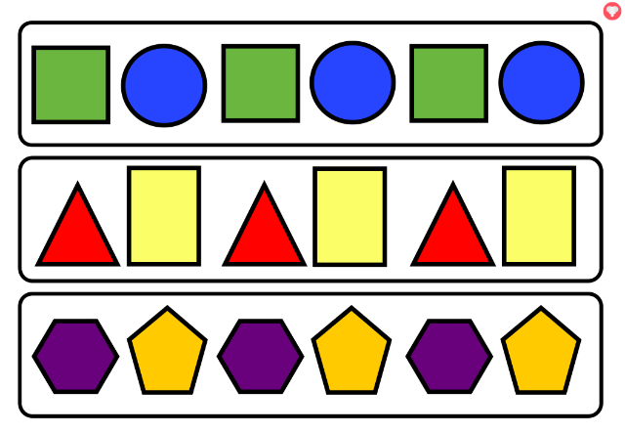  Or more complicated ones like this: 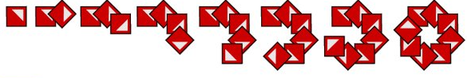Or even using lines of symmetry to make the pattern:  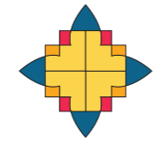 | Have a watch of the first video and then work through the questions on page 65. The first video will also give you more information about the challenge referred to below!  Challenge – Can you make your own shape pattern? Make it as hard as you can! Can you make something as tricky as the one at the bottom of page 64? Don’t tell your mum or dad what they pattern is, can they guess it?  Come back and watch the second video for your answers.
Afternoon Activity:  Science | How many different materials can your child name?  Watch these 2 clips, can they name all the materials they see?  https://www.bbc.co.uk/bitesize/clips/z7qd7ty  https://www.bbc.co.uk/bitesize/clips/zm2jmp3  There’s also this interactive picture to help them think about what materials are found in the home.  https://www.bbc.co.uk/bitesize/topics/zrssgk7/articles/z9pgcdm | Have a watch of the introductory video to the materials hunt!  We want you to roam your house looking for objects made of different materials, at least two.  Draw a line down the middle of a page over your exercise book, on one side draw the object and on the other side write down the materials it’s made of.  What’s the most unusual material in your house?
Physical Education idea | Off to space again!  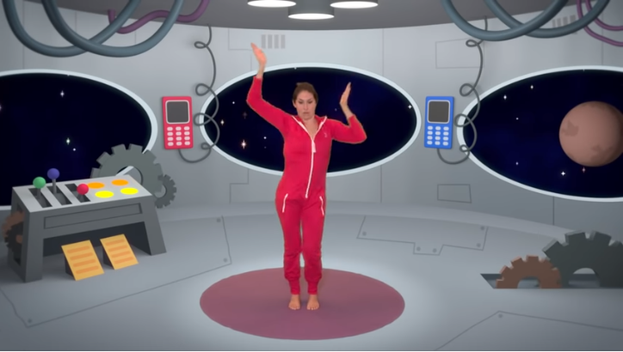  https://www.youtube.com/watch?v=LZAaZDVqCiA
Mindfulness | 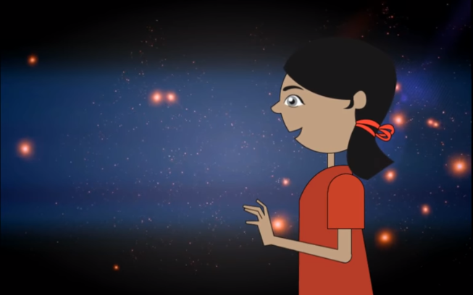  https://www.youtube.com/watch?v=fmWYD6aHLhg  What does being present mean for children?
Reading and  Story time | Read for at least 10 mins. Can you find any words with the focus sounds in your book?  Why not share a virtual story time together?  All being well, one will be uploaded to the Year Two page each afternoon from each class teacher. | Oxford Owl eBooks  https://www.oxfordowl.co.uk/for-home/reading/

